**Request:**

**From:** Phoen, Eugene   
**Sent:** Friday, October 13, 2017 10:26 AM  
**To:** Chan, Pei-Fong; Lee, Kar Mei  
**Cc:** Low, Dennis; Tan, Christina  
**Subject:** RE: Enquries

Hi Pei Fong,

How about something like this:

|  |  |  |  |
| --- | --- | --- | --- |
| WMS Report | Generate by | Example | Used for |
| Outbound Handling | Date range | |  |  |  |  |  |  |  |  | | --- | --- | --- | --- | --- | --- | --- | --- | | Drop date/time | DO# | Stream | GI date/time | Ship out date/time | No. order lines | No. pick lines | Qty | |  |  | SWAP/STO/SP |  |  |  |  |  | | KPI - Outbound leadtime, KPI - delivery quality, billing – outbound handling |
| Inbound handling | Date range | |  |  |  |  |  |  | | --- | --- | --- | --- | --- | --- | | PO# | Stream | Finalize date/time | No. order lines | No. putaway lines | Qty | |  | SWAP/STO/SP |  |  |  |  | | KPI – Inbound leadtime, billing – inbound handling |
| Inventory Accuracy – CC var | Date range | |  |  |  |  |  |  | | --- | --- | --- | --- | --- | --- | | SKU | Stream | Unit price | Counted | Discrepancy (qty) | Discrepancy (value) | |  | SWAP/STO/SP |  |  |  |  | | KPI - Inventory accuracy, KPI - stock consistency |
| Master – SKU | Commodity code | |  |  | | --- | --- | | SKU | Last count date | |  |  | | KPI - Cycle count performance |
| Daily inventory Snapshot | Date specific | |  |  |  |  |  |  | | --- | --- | --- | --- | --- | --- | | Type | Type | Storage bin | LP | SKU | Qty | | Shelf/rack | AIRCON/NONAC |  |  |  |  |   *  Count of AIRCON racking bins occupied:  Count of NONAC racking bins occupied:  Count of AIRCON shelving tiers occupied:  Count of NONAC shelving tiers occupied: | Inventory snapshot, Billing – storage |
| TBC | Date range (putaway to rack/empty tier) | |  |  |  |  |  |  | | --- | --- | --- | --- | --- | --- | | Type | Type | Storage bin | PO# | SKU | Qty | | Shelf/rack | AIRCON/NONAC |  |  |  |  |   *  Count of AIRCON racking bins putaways:  Count of NONAC racking bins putaways:  Count of AIRCON shelving tiers putaway: ^  Count of NONAC shelving tiers putaway: ^ | Billing – storage |

* Summary at bottom

^ Is it difficult to count putaway to empty tiers? Eg putaway to a shelving bin when no other bin in that tier is occupied

# WMS Update – 2017.10.30

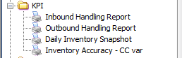

## KPI – Inbound Handling Report

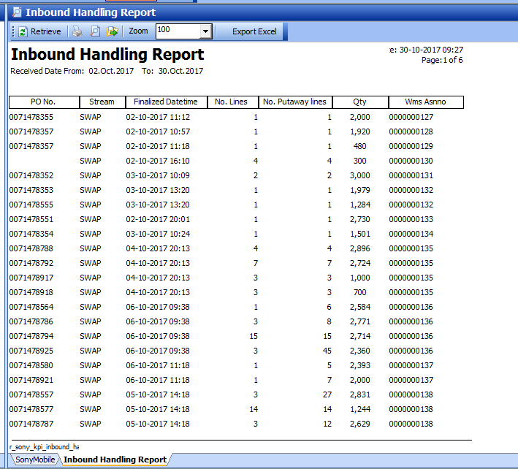

## KPI – Outbound handling

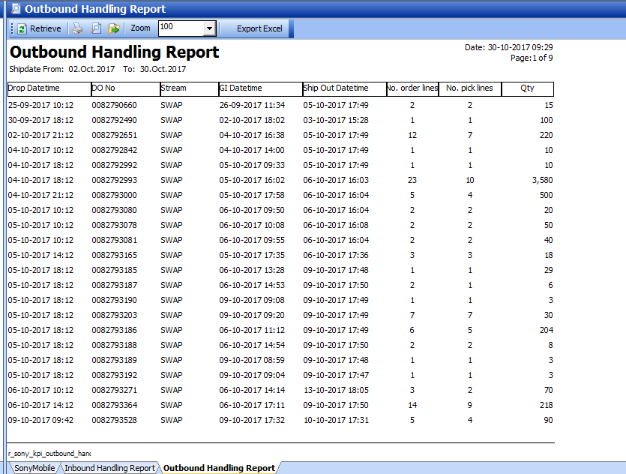

# Pick lines = Count unique by ID, LOC, SKU

## KPI – Daily Inventory

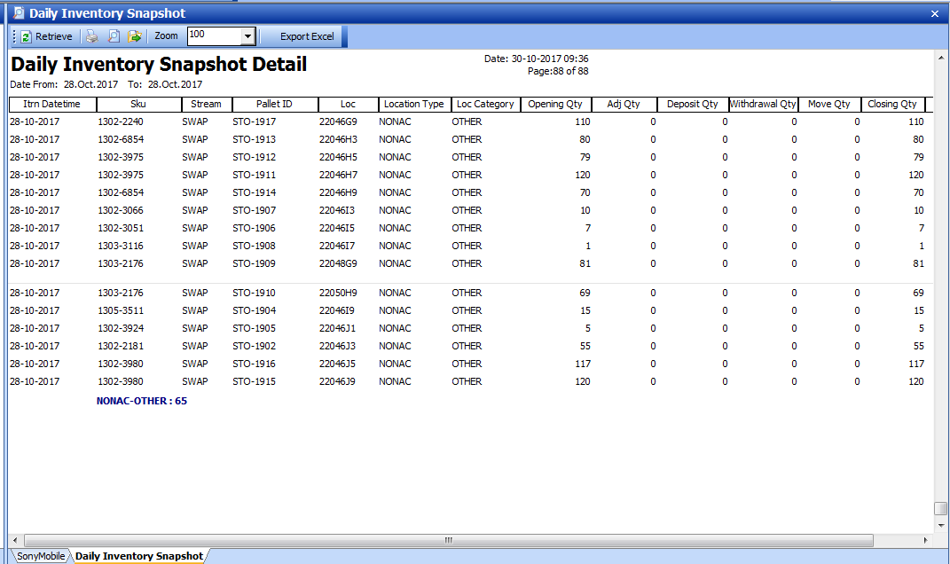

## Inventory Accuracy – CC var

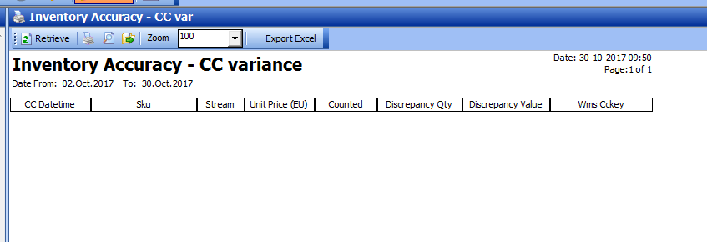

## SKU – Last Cycle Count



